**Bug Report**

Bug title: Timeslot permutation error  
Description: Duplicated courses in the timetable.

Product: Schedule

Version: 8

Platform: PC

OS: Window 7

Severity: Normal

Updated: 29/11/2014 reported by Lo Weng Kuai

Assigned to: Lo Weng Kuai

Actual Output:

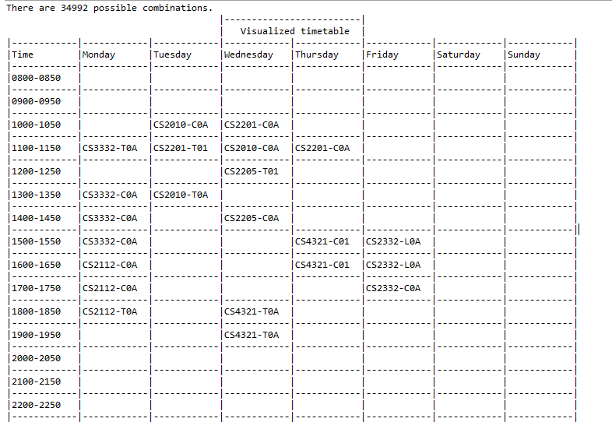

Expected Output:

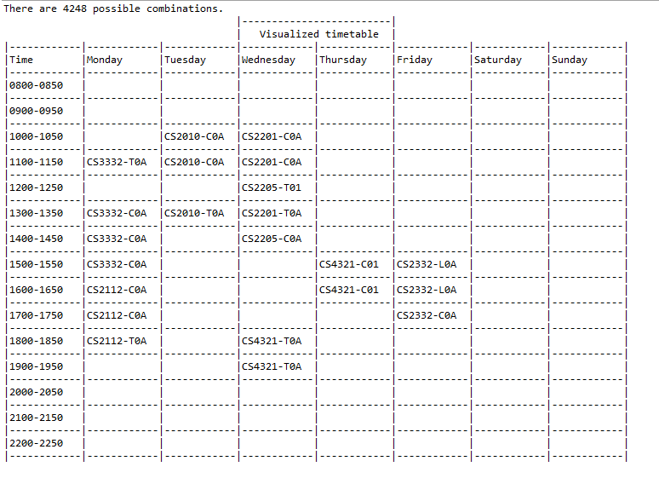

Lo Weng Kuai 29/11/2014 18:32

When generate the timetable, the class with same course session should be ion the same day. Each session should have a unique session id. But the result show that the course with the same session id appear on two different days.

This bug cause error and not corrects permutation result. Therefore I change the codes in the main, to correct this error and debug.

Before:

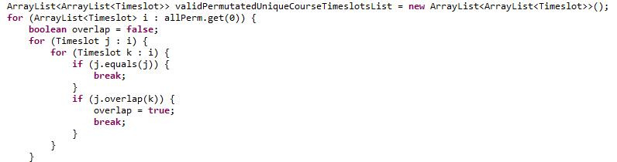

After:

